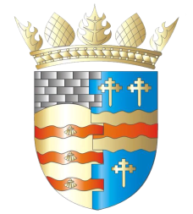**BLAIRGOWRIE AND RATTRAY COMMUNITY COUNCIL**

**Ordinary Meeting – Draft Agenda**

**Thursday, 14th August 2025, at 7pm**

**at the BaRI Building, High Street, Blairgowrie,**

**and online via Zoom**

1. Welcome and Introductions

2. Apologies

3. Adoption of draft minutes of 12st June 2025 meeting  
4. Police & Fire Reports

a) Riverside safety

5. Matters raised by members of the public

a) Traffic

b) Top up tap

6. Regular reports

a) Resilience/Flooding/First Responders PR/SM

b) Climate Action DC/GP/JM

c) Twinning GP/SM/DC/AS

d) Maintenance in Blairgowrie & Rattray

i. Built Environment

a) Electrical Connections at Wellmeadow (B&R Common Good Fund?)

ii. Open Spaces

e) Local Place Plan

f) Citizen/Young Person/Group of the Year

7. Matters Arising/Reports Back

a) Emma Street laundry

b) Football Pitch

c) Gallowbank Footpath

d) Representation of Young People

8. Remembrance Day wreath

9. Highland Games

10. Community Council Elections

11. Traffic Matters

a) Speeding Meeting

12. Planning Matters

13. Chair’s Report

14. Treasurer’s Report

15. Councillors’ Reports

16. AOCB

Please note: With the permission of all attendees, the minute taker will record this meeting solely for the purpose of writing up the minutes, will not share the recording, and will delete the recording as soon as the minutes have been written. The Chair will ask for permission at the start of the meeting.

Awaiting info: CCTV, Community Action Plan

**Next meeting: Ordinary Meeting, Thursday, 11th September 2025, 7.00pm**